**~ BY ANANYA SARKAR**

**Case Study on per capita consumption of Electricity in India (a dataset on conservation of energy resources) makes for an interesting reading.**

**The State of Goa (2025-2098 kWh) & Puducherry (2125-2693 kWh) account for maximum per capita consumption of electricity within 2006 and 2012. While states of Bihar (91-134 kWh), Manipur (195-236 kWh) & Assam (175-250 kWh) show the lowest per capita consumption. The National Average per capita electricity consumption is 778.63 ( https://data.gov.in/catalog/capita-consumption-electricity).15 states in India show lower annual per capita power consumption in comparison of national average!**

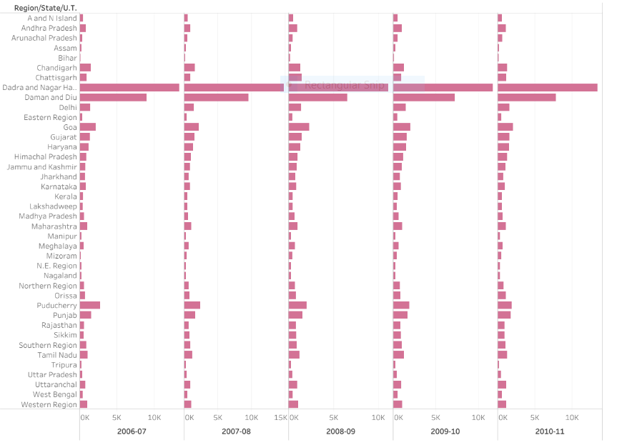

**The above graph includes 2 Union Territories – Dadra & Nagar Haveli, Daman & Diu – as the consumption of electricity in both these places is ten times that of National average. One of the reasons being that these are ports & Industrial places with very less residential consumption of Electricity. So the figures in those 2 UT’s show unusually high. It is interesting to note that on national level,** [**India’s energy consumption is already one of the lowest in the world**](https://trak.in/tags/business/2010/04/07/top-energy-consuming-countries/)**. And if you consider states like Bihar, they live on fraction of electricity as compared to developed world!**

**As regard to the relative consumption of various sources of energy as percent of the world total, India among the emerging Asian economies, occupies third place immediately after China and Japan. With existing technologies, increasing per capita productivity needed to increase per capita income requires increasing amounts of energy. Kerala’s consumption is predominantly domestic, which accounts for 49 percent of the total consumption, which is only 22 percent of nation-wide. The critical role played by the availability of energy and other infrastructure in stimulating investment and modernization has been recognized right from the first five year plan.**

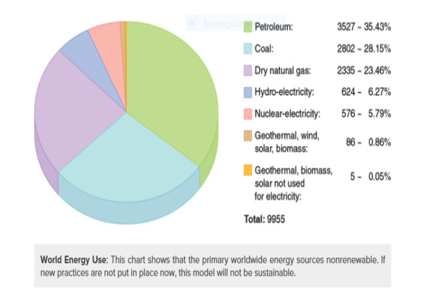

**Increasing pressure of population and increasing use of energy in different sectors of the economy is an area of concern for India. The use of coal for electricity generation in India is expected to increase by 2.2 percent per annum during 2002–25, thus requiring an additional 59 000 MW of coal-fired capacity. Oil demand in India is expected to increase by 3.5 percent per annum during the same time. It is quite apparent that coal will continue to be the predominant form of energy in future. However, imports of petroleum and gas would continue to increase substantially in absolute terms, involving a large energy import bill. There is, therefore, an urgent need to conserve energy and reduce energy requirements by demand-side management and by adopting more efficient technologies in all sectors.**

* **THE STRATEGIES WE SHOULD FOLLOW:**

1. **As non-renewable energy sources start to run out, the world is now starting to see the effects of climate change and the impacts fossil fuels have on the environment. Therefore its imperative we change from fossil fuels to more renewable resources to benefit our future generations. We will also see the health impacts climate change will have on the world, as the atmosphere starts to build up to harmful gas it prevents the heat from earth escaping. Creating a multitude of health issues as bugs and bacteria cultivate in warmer climates.**
2. **Renewable energy is excellent for country independence; countries are not reliant on others to provide them with energy. This also works when it comes to households if you are to use solar panels in your home and do not use all the energy created by them, this energy goes back to the energy company, and you might find that they have to repay you for it. Finally by opting for green renewable energy sources will help reduce the cost of your** [**electricity supply for your home.**](https://www.ampoweruk.com/for-home/electricity)



***Some solutions are relatively simple and would provide economic benefits: implementing measures to conserve energy, putting a price on carbon through taxes and cap-and-trade and shifting from fossil fuels to clean and renewable energy sources.  
 ~David Suzuki***

